# General approaches

Modeling interindividual variation in internal doses in humans using PBPK models requires data on the variation in physiological parameters across the population of interest.

*Price, Paul S et al. "Modeling interindividual variation in physiological factors used in PBPK models of humans." Critical reviews in toxicology 33.5 (2003): 469-503.*

{Price2003}

* Large set of equations for organs and blood flow based on NHANES III

*Willmann, Stefan et al. "Development of a physiology-based whole-body population model for assessing the influence of individual variability on the pharmacokinetics of drugs." Journal of pharmacokinetics and pharmacodynamics 34.3 (2007): 401-431.*

A physiology-based pharmacokinetic (PBPK) population model was developed that makes use of known distributions of physiological and anthropometric properties obtained from literature for realistic populations. As input parameters the model requires **race, gender, age** and two parameters out of **body weight**, **height** and **BMI**.

# Formulas for scaling

## BSA (body surface area)

Several authors have developed formulae to estimate the surface area of the

body (Dubois and Dubois, 1916; Boyd, 1935; Gehan and George, 1970; Haycock et

al., 1978; Lentner, 1984). These formulae generally are of the form:

BSA = a0 *H^a1 * M^a2

where BSA is surface area (m2), H is height (cm), and M is mass (kg). {Valentin2002}

Calculation of BSA using Mosteller’s formula {Moesteller1987}

BSA = f (height [cm], weight[cm]

$BSA[m²] = \sqrt{(height [cm] * weight [kg]/3600[m^{4}/kg/cm])}$

Calculation of BSA using classic DuBois’s formula {Moesteller1987}

$BSA[m²] =0.007184*{height[cm]}^{0.725}$ ${*weight[kg]}^{0.425}$

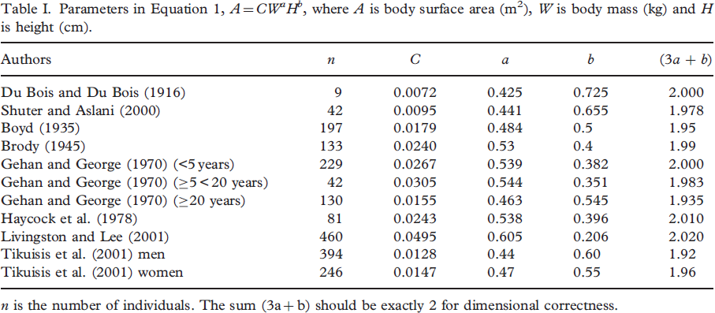

{Burton2008}

**BMI (body mass index)**

BMI = f(weight[kg], height[m])

$BMI [kg/m^{2}] = \frac{weight [kg]}{{(height [m])}^{2}}$

**TLV (total liver volume)**

The estimation of the standard liver volume (SLV) is an important component of the evaluation of potential living liver donors and the surgical planning for resection for tumors. At least 16 different formulas for estimating SLV have been published in the worldwide literature.

{Pomposelli2012}

**Caucasian population**

**n=1332** (autopsy liver German)

TLV [ml] = f (BSA)

TLV [ml]= -345.7 [ml] + 1072.8 [ml/m²] * BSA [m²]

{Heinemann1999}

**western adults**

**n=292**

TLV [ml] = f (BSA)

TLV [ml]= -794.41 [ml] + 1267.28 [ml/m²] * BSA [m²]

TLV [ml]= f (bodyweight)

TLV [ml] = 191.80 [ml] + 18.51 [ml/kg] * weight [kg]

{Vauthey2002}

**pediatric and adult japanese**

**n=96** (65 pediatric, 31 adolescent and adult subjects)

TLV = f (BSA)

TLV [ml] = 2.4 [ml] + 706.2 [ml/kg] * BSA [m²]

{Urata1995}

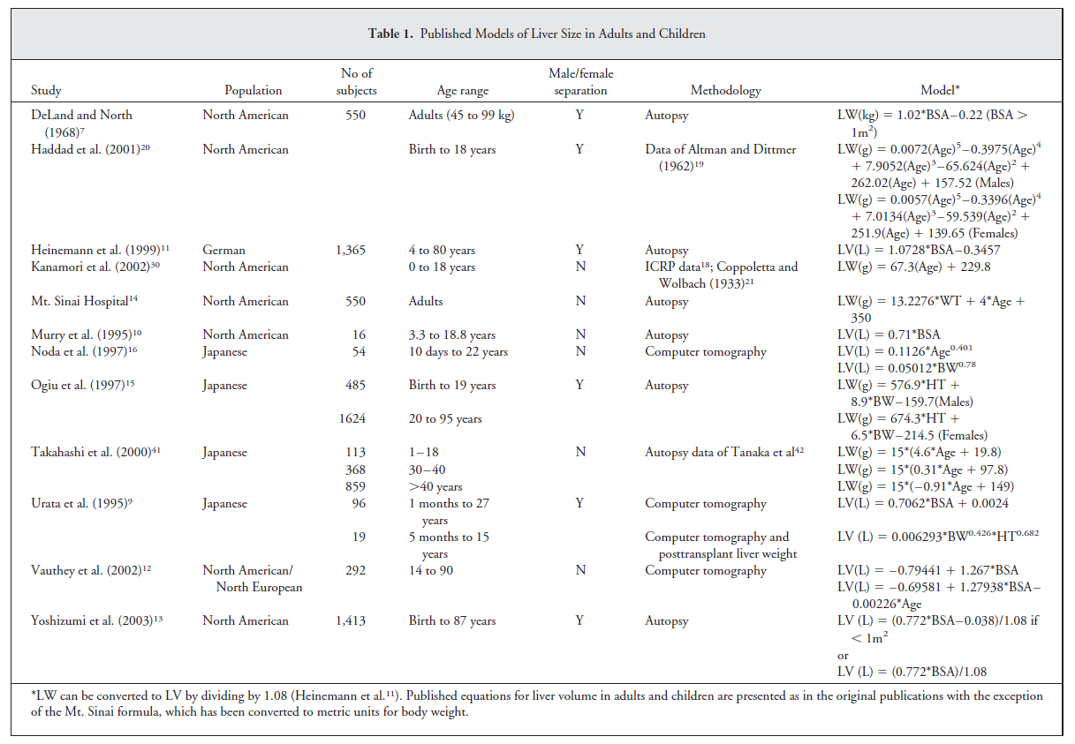

{Johnson2005}

**TLW (total liver weight)**

TLW [g] = f (bodyweight, age)

TLV [g]= 13.2276[g/kg] * bodyweight [kg] + 4 [g/years] * age [years] + 350 [g]

{Emre2001}

**TLV (total liver volume)**

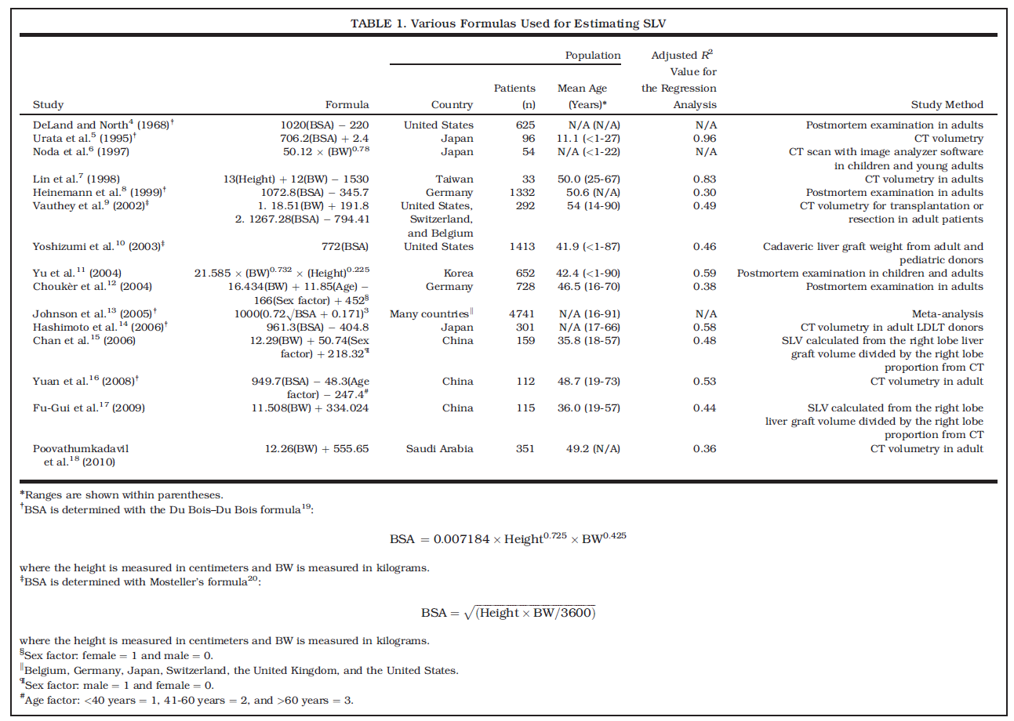

{Pomposelli2012}

# References

Burton, Richard F. "Estimating body surface area from mass and height: theory and the formula of Du Bois and Du Bois." *Annals of human biology* 35.2 (2008): 170-184.

Emre, Sukru et al. "Safety and risk of using pediatric donor livers in adult liver transplantation." *Liver Transplantation* 7.1 (2001): 41-47.

Heinemann, Axel et al. "Standard liver volume in the Caucasian population." *Liver transplantation and surgery* 5.5 (1999): 366-368.

Johnson, Trevor N et al. "Changes in liver volume from birth to adulthood: A meta‐analysis." *Liver transplantation* 11.12 (2005): 1481-1493.

Mosteller, RD. "Simplified calculation of body-surface area." *The New England journal of medicine* 317.17 (1987): 1098.

Pomposelli, James J et al. "Variability of standard liver volume estimation versus software‐assisted total liver volume measurement." *Liver Transplantation* 18.9 (2012): 1083-1092.

Urata, Koichi et al. "Calculation of child and adult standard liver volume for liver transplantation." *Hepatology* 21.5 (1995): 1317-1321.

Valentin, Jack. "Basic anatomical and physiological data for use in radiological protection: reference values: ICRP Publication 89." *Annals of the ICRP* 32.3 (2002): 1-277.

Vauthey, Jean‐Nicolas et al. "Body surface area and body weight predict total liver volume in Western adults." *Liver transplantation* 8.3 (2002): 233-240.

Willmann, Stefan et al. "Development of a physiology-based whole-body population model for assessing the influence of individual variability on the pharmacokinetics of drugs." *Journal of pharmacokinetics and pharmacodynamics* 34.3 (2007): 401-431.